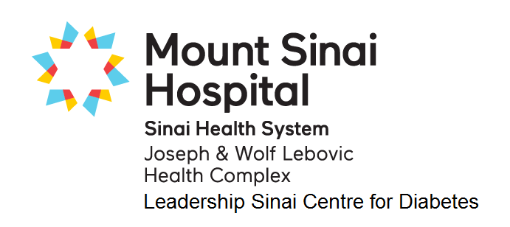
GDM FOOD RECORD

Name: |  |  |  |  |  |  | Date:
Meal  Record what you eat and drink.  Include portion sizes and the number of carb choices. |  |  |  |  |  |  |  | # of Carb Choices | Suggested # of Carb Choices
before breakfast blood sugar: |  |  |  |  | mmol/L time:
Breakfast time: |  |  |  |  |  |  |  |  | 3-4
1 hour after breakfast blood sugar: |  |  |  |  | mmol/L time:
Snack time: |  |  |  |  |  |  |  |  | 1-2
Lunch time: |  |  |  |  |  |  |  |  | 3-4
1 hour after lunch blood sugar: |  |  |  |  | mmol/L time:
Snack time: |  |  |  |  |  |  |  |  | 1-2
Dinner time: |  |  |  |  |  |  |  |  | 3-4
1 hour after dinner blood sugar: |  |  |  |  | mmol/L time:
Snack time: |  |  |  |  |  |  |  |  | 1-2
DAILY TOTAL |  |  |  |  |  |  |  |  | min. 12/day


GDM FOOD RECORD

Name: |  |  |  |  |  |  | Date:
Meal  Record what you eat and drink.  Include portion sizes and the number of carb choices. |  |  |  |  |  |  |  | # of Carb Choices | Suggested # of Carb Choices
before breakfast blood sugar: |  |  |  |  | mmol/L time:
Breakfast time: |  |  |  |  |  |  |  |  | 3-4
1 hour after breakfast blood sugar: |  |  |  |  | mmol/L time:
Snack time: |  |  |  |  |  |  |  |  | 1-2
Lunch time: |  |  |  |  |  |  |  |  | 3-4
1 hour after lunch blood sugar: |  |  |  |  | mmol/L time:
Snack time: |  |  |  |  |  |  |  |  | 1-2
Dinner time: |  |  |  |  |  |  |  |  | 3-4
1 hour after dinner blood sugar: |  |  |  |  | mmol/L time:
Snack time: |  |  |  |  |  |  |  |  | 1-2
DAILY TOTAL |  |  |  |  |  |  |  |  | min. 12/day

